Multiple-choice section

|  |  |  |  |  |  |  |  |  |  |  |  |
| --- | --- | --- | --- | --- | --- | --- | --- | --- | --- | --- | --- |
| Question | 1 | 2 | 3 | 4 | 5 | 6 | 7 | 8 | 9 | 10 | 11 |
| Answer | C | A | B | D | C | D | A | C | B | C | A |

Question 1 [2.1]

C

10 × 1 = 10

10 × 2 = 20  
10 × 3 = 30

10 × 4 = 40

Question 2 [2.2]

A

The first five prime numbers are 2, 3, 5, 7, 11

0, 1, 4 and 9 are not prime numbers.

Question 3 [2.4]

B

2 < 9

Question 4 [2.5]

D

8 – 6 + 2 = 4

Question 5 [2.1]

C

50 doesn’t divide evenly into 3, 6, or 15.

50 is divisible by 5.

Question 6 [2.4]

D

3, 5, 7, 9 is the only set of numbers in ascending order.

Set A and C are in no clear order. Set B is in descending order.

Question 7 [2.6]

A

7 – (-3) = 7 + 3 = 10

Question 8 [2.7]

C

-15 – (-1) – (+1) = -15 + 1 – 1

Question 9 [2.3]

B

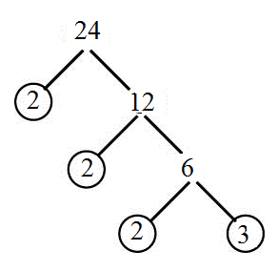

2 × 2 × 2 × 3

Question 10 [2.2]

C

7, 29 and 19 are prime numbers.

27 is composite.

Factors of 27 are 1, 3, 9, 27

Question 11 [2.1]

A

10: 1, 2, 5, 10

15: 1, 3, 5, 15

HCF 5

Multiple-choice total marks: 11

Short answer section

Question 12 3 marks [2.1]

(a) A number is divisible by 2 if the last digit is an even number.

(b) A number is divisible by 5 if the last digit is 0 or 5.

(c) A number is divisible by 3 if the sum of the digits is divisible by 3.

Question 13 3 marks [2.1]

Multiples of 4: 4, 8, 12, 16, 20

Multiplies of 6: 6, 12, 18, 24, 30

LCM of 4 and 6 = 12

Question 14 3 marks [2.1]

18 and 20

18: 1, 2, 3, 6, 9, 18

20: 1, 2, 4, 5, 10, 20

HCF: 2

Question 15 2 marks [2.1]

|  |  |  |
| --- | --- | --- |
| **÷ 2** | **÷ 5** | **÷10** |
| 25 not even  Do not shade 25 | Ends in 0 or 5, so is ÷ 5 | Does not end in 0, so is NOT ÷ 10 |
| 30 even, so ÷ 2 | Ends in 0 or 5, so is ÷ 5 | Ends in 0, so is ÷ 10 |
| 16 even, so ÷ 2 | Does not end in 0 or 5, so is NOT ÷ 5 Do not shade 16 | Does not end in 0, so is NOT ÷ 10 |
| 70 even, so ÷ 2 | Ends in 0 or 5, so is ÷ 5 | Ends in 0, so is ÷ 10 |



Question 16 1 mark [2.2]

2, 3, 5, 7, 11

Question 17 3 marks [2.2]

9 and 15 are not co-prime because their HCF is 3. For any numbers to be co-prime, their HCF must be 1.

Factors of 9: 1, 3, 9

Factors of 15: 1, 3, 5, 15

Common factors are 1 and 3

Question 18 2 marks [2.2]

47, 48

22, ~~23~~, 24

18, ~~19~~, 20

1, ~~2, 3~~, 4

Question 19 2 marks [2.3]

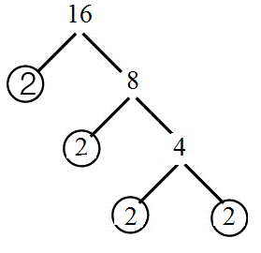

16 = 2 × 2 × 2 × 2 = 24

Question 20 2 marks [2.3]

32 × 22

= 3 × 3 × 2 × 2

= 9 × 4

= 36

Question 21 2 marks [2.4]

(a) 10 m above the ground = + 10 m

(b) 6 °C below zero = -6 °C

Question 22 3 marks [2.4]

(a) +12 > -8

(b) -6 < -2

(c) 0 > -1

Question 23 2 marks [2.4]

-3, -1, 0, 1, 5, 15

Question 24 2 marks [2.4]

20, 5, -5, -15, -20, -25

Question 25 3 marks [2.4]

(a) 134 + 9 = 143 m

(b) 141 – 49 = 92 m

Question 26 2 marks [2.7]

-12 – (-2) + -1 + 4

= -12 + 2 – 1 + 4

= -12 + 1 + 4

= -12 + 5 = -7

Question 27 3 marks [2.5]

(a) 9 + 13 = 22 (b) -3 + 23 = 20 (c) 24 – 14 = 10

Question 28 4 marks [2.5]

(a) -3 + 4 + 1  
= -3 + 5  
= 2  
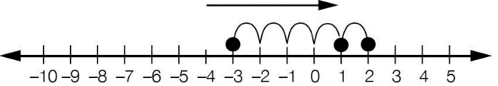

(b) 18 – 15 – 9  
= 3 – 9  
= -6



Question 29 2 marks [2.6]

(a) -3 + 4 + (-1)

(b) -3 + 4 – 1 = 0 Julia ended up where she started

Question 30 2 marks [2.7]

(a) 20 – (-5) = 20 + 5:

True: two like signs means add.

(b) 35 + (-10) = 35 + 10

False: two unlike signs means subtract.

Question 31 2 marks [2.7]

|  |  |
| --- | --- |
| (a) Recall: - (-) = +  -(-5) = 5 | (b) Recall: + (-) = - +(-11) = -11 |
| (c) Recall: - (+) = - -(+9) = -9 | (d) Recall: + (+) = + +(+32) = 32 |

Question 32 2 marks [2.6]

4 – 12 + 6  
= -8 + 6  
= -2

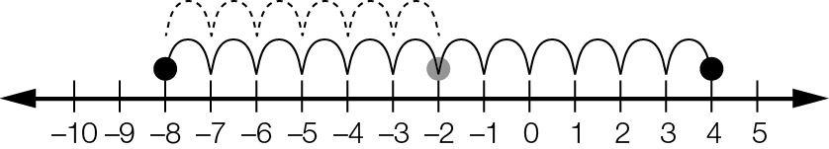

Question 33 2 marks [2.6]

Card B: -27 + -3 = -30

Short answer total: 52

Extended answer section

Question 34 5 marks [2.7]

(a) -39 °C

(b) August

(c) December

(d) -61 – -28  
= -61 + 28   
= 33 °C

Extended answer total: 5

TOTAL test marks: 68